**Management portal bug list:**

1. Reports-State tax-For specific tails like, 105ST,109CH,119JE,121GZ,12260,131YF, after select any one of these tails and select “Jan/2021” in from month and select “Jan/2022” in to month and click view button details are displayed and no alert message is displayed. This issue occurs only select the above mentioned tails only.

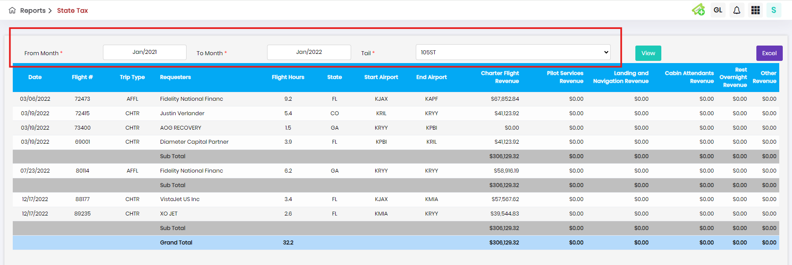

1. MS-Report-Prepare MS Report-After select any tail(I have select 807LA Tail) and click edit button, In hide transcation and Expense Attach Invoice tab, for aircraft miscellaneous expense, previous month details also displayed.

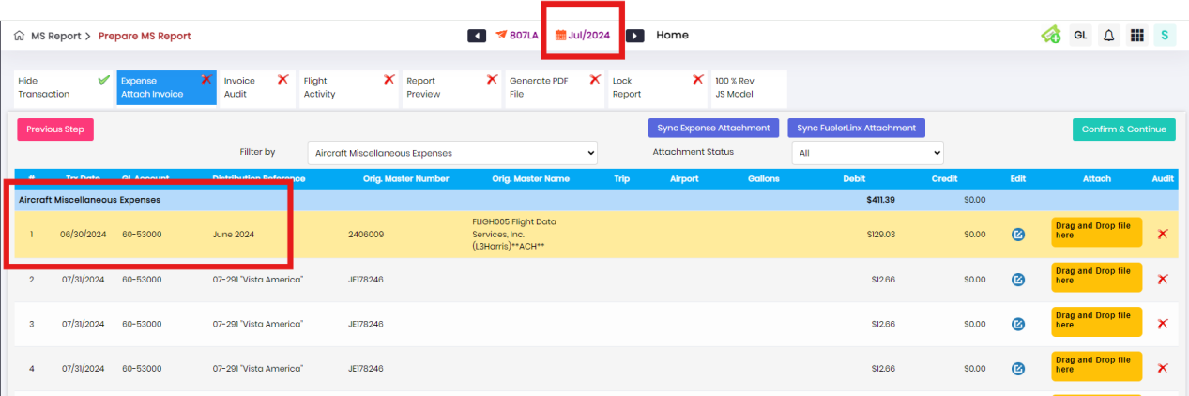

1. MS-Report-Prepare MS Report-After select any tail(I have select 109CH Tail) and click edit button,

In Revenue owner pay tab, after click attach button in ORA or Quote column, after upload valid file in ORA Agreement tab only and click save button. Then again click attach button in Quote column and upload valid file in Quote agreement tab and click save button, previous uploaded file is removed in ORA column automatically.

First Upload:

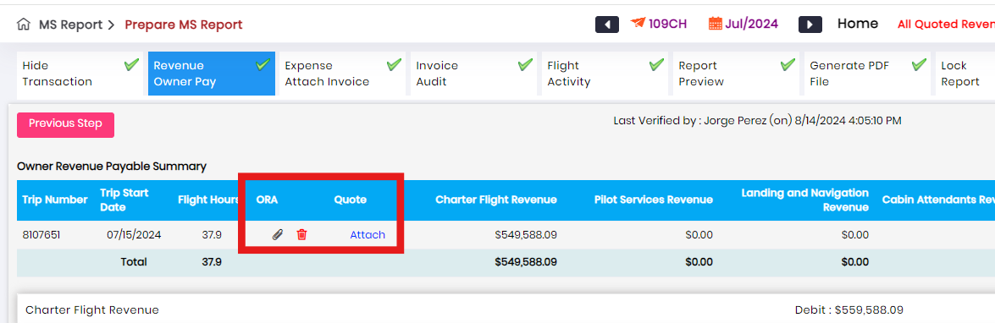

Second Upload:

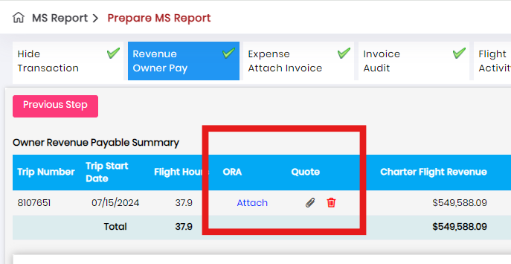

1. MS-Report-Prepare MS Report-After select any tail(I have select 109CH Tail) and click edit button, In Generate PDF File tab, Click Regenerate MS Report, system generated report radio button and click system generated radio button and as well as manual upload radio button, then enter valid details and click “Click to generate” button, invalid error toast.

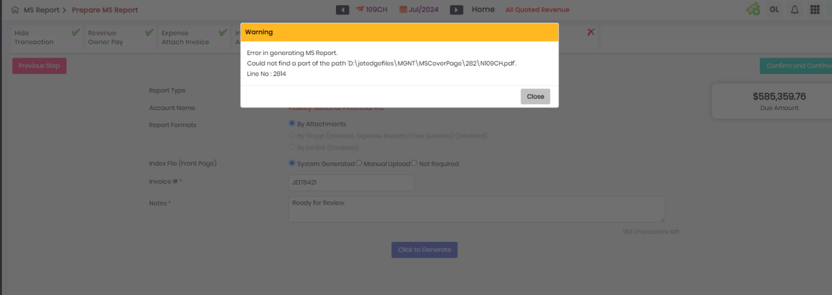

1. MS-Report-Prepare MS Report-After select any tail(I have select 109CH Tail) and click edit button, in lock report tab, without enter any details in notes field and click lock report error toast is appeared but spelling is wrong.

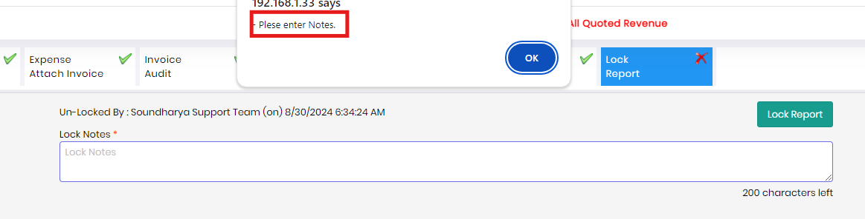

1. MS-Report-Prepare MS Report-After lock the report in any tail but user can able to update the data in any tab.
2. Owner portal-Owner setup-Click add owner- Tail mapping should be mandatory status.

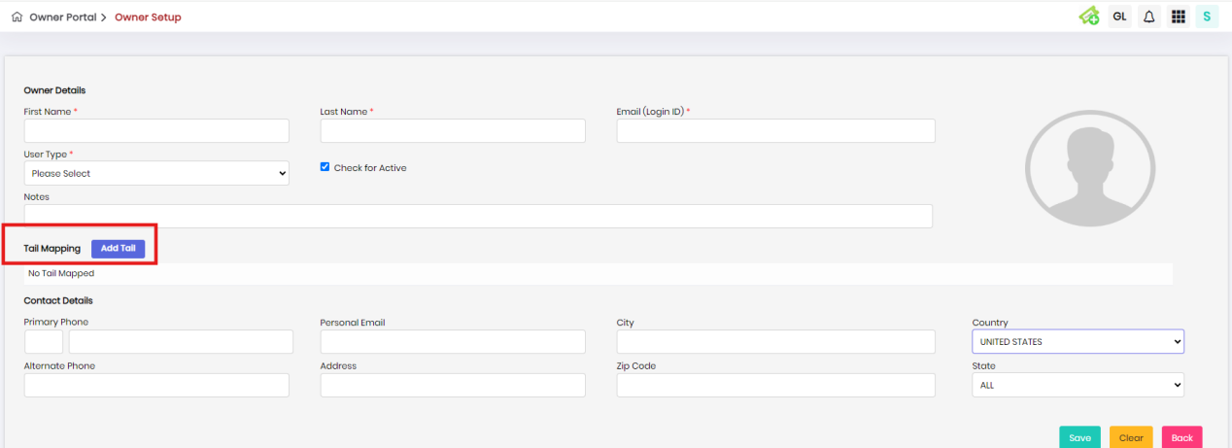

1. Reports-State Tax-Tail dropdowm first option is showing like “ALL” but it need to show “Please Select” option.

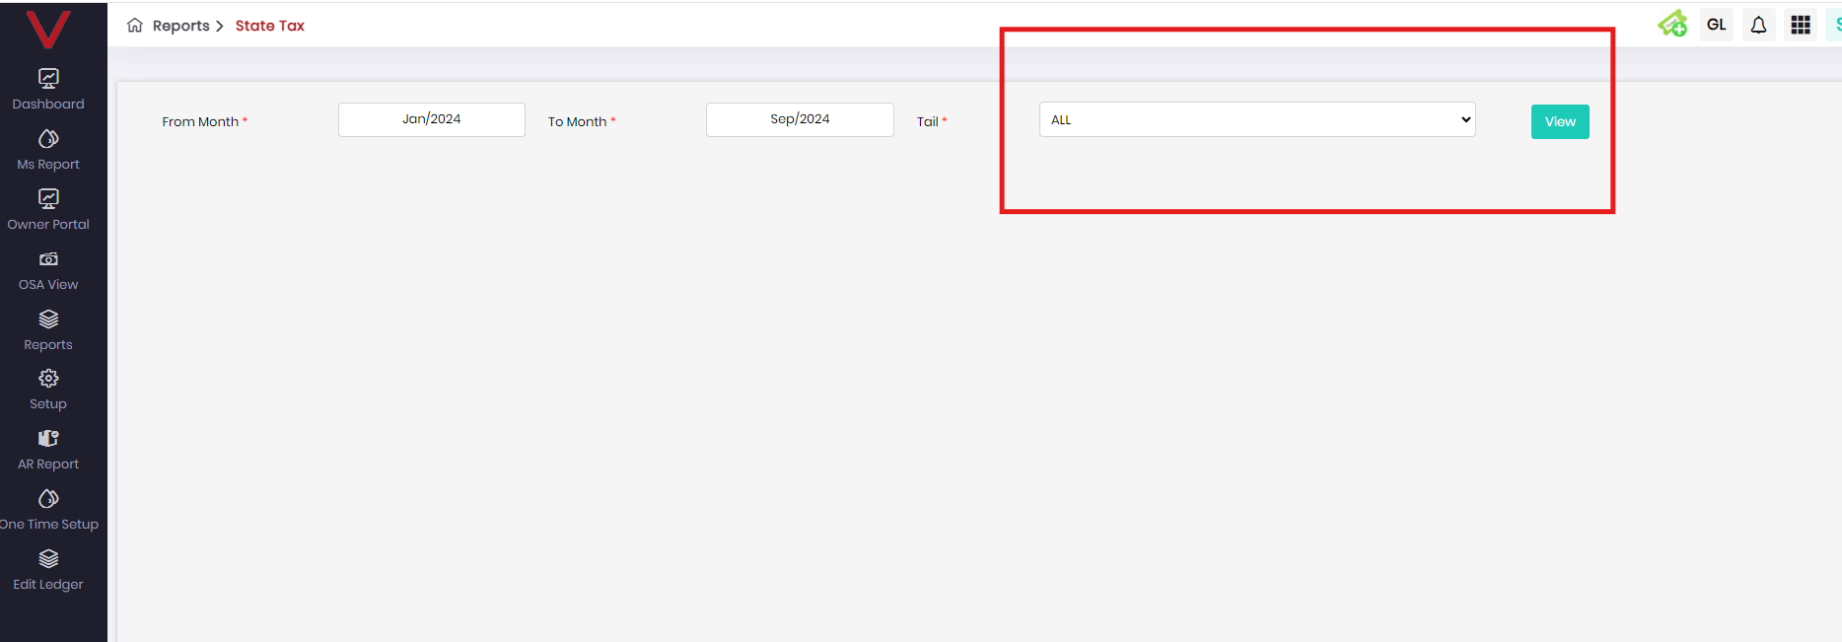

1. In Edit Ledger-

* When select 08/01/2024 in from calendar and 08/31/2024 in to calendar error select 109CH tail and GL Code enter as 40000-Charter Flight Revenue and select Both radio button in account field and click view button error toast appear like in below screenshot.

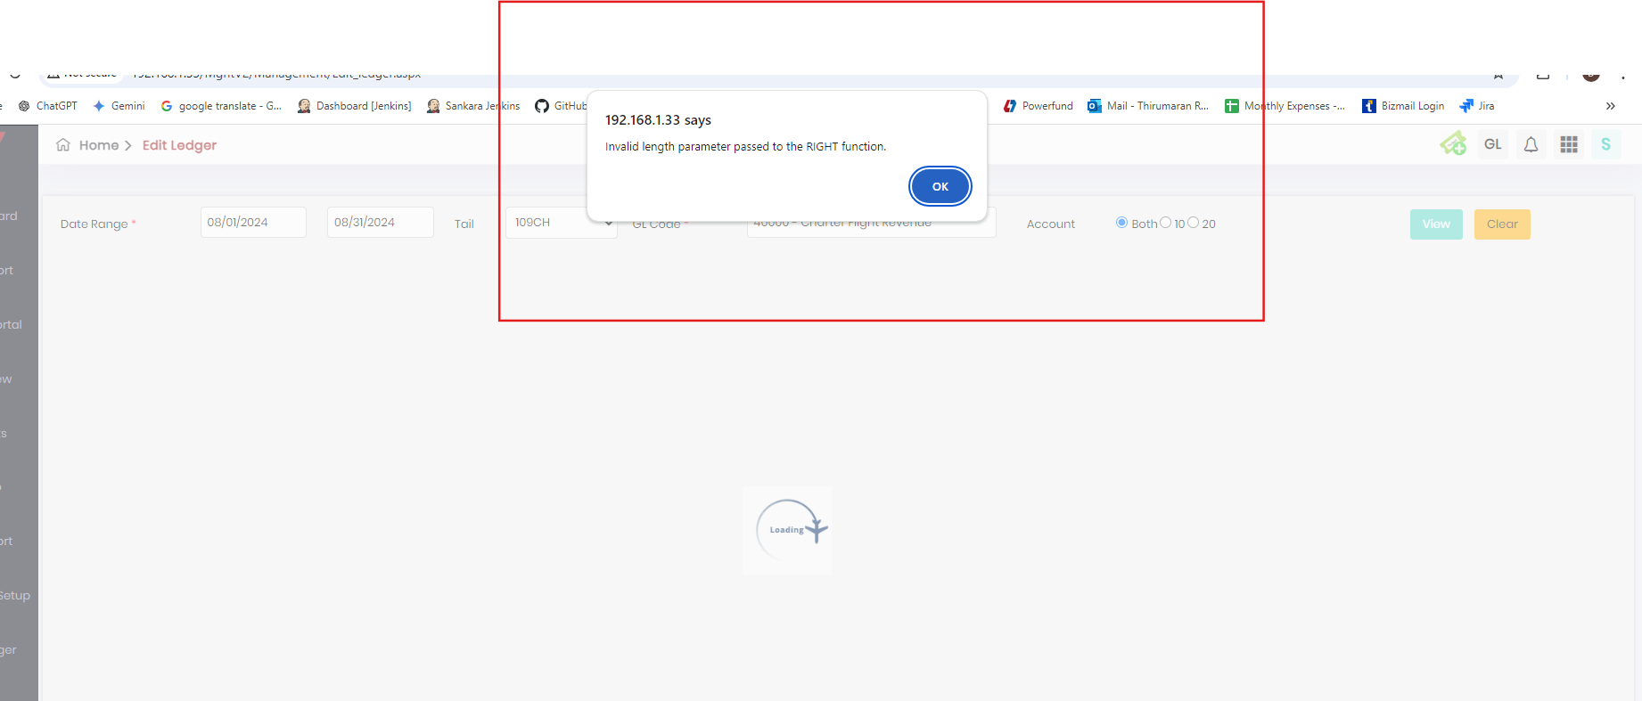

* When select 01/01/2024 in from calendar and 08/31/2024 in to calendar error select 109CH tail and GL Code enter as 40000-Charter Flight Revenue and select Both radio button in account field and click view button error toast appear like in below screenshot.

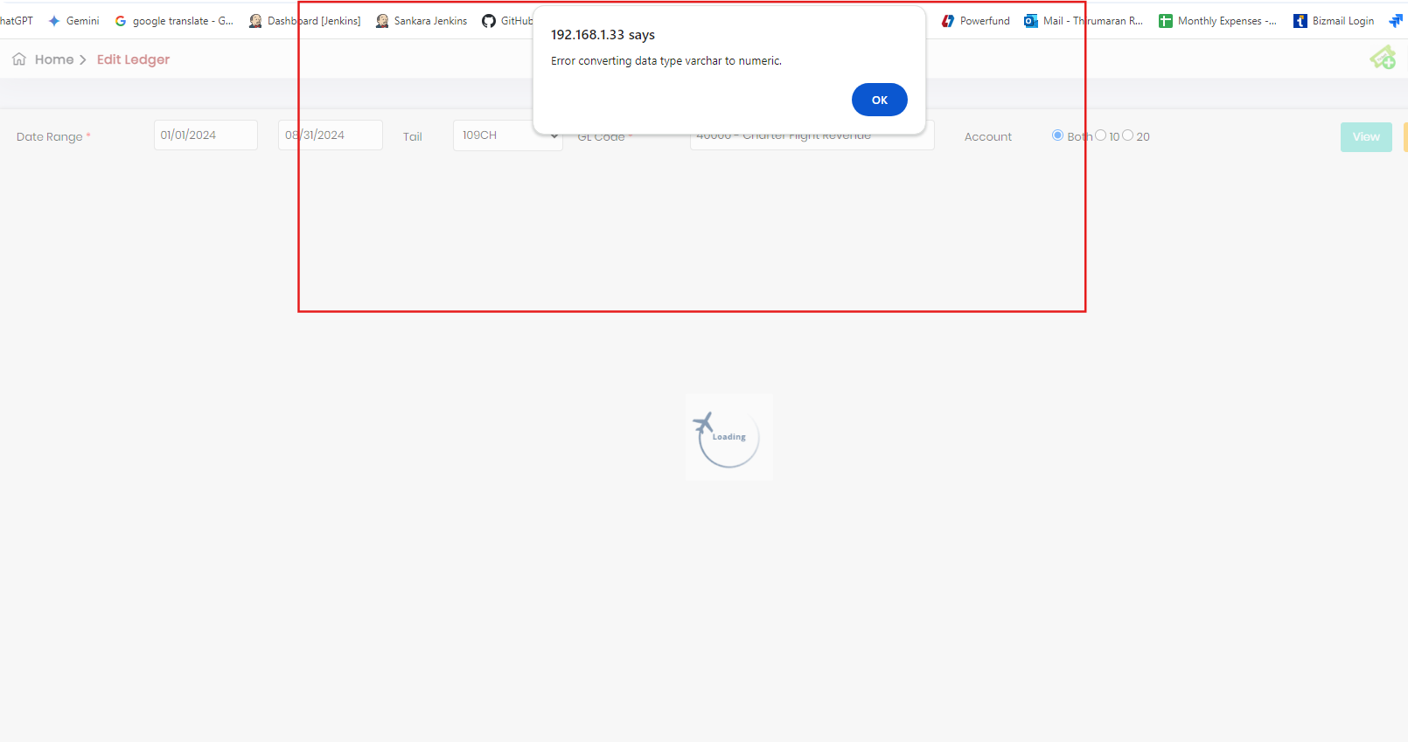

1. In overall modules when “from and to calendar” type calendar tabs is present, when from date is given higher than to calendar tab like, in from tab select Dec/2024 and in To calendar tab select Jan/2024, no error message is appearead. But it need to show “From date is smaller than To date” orelse any other valid toast.